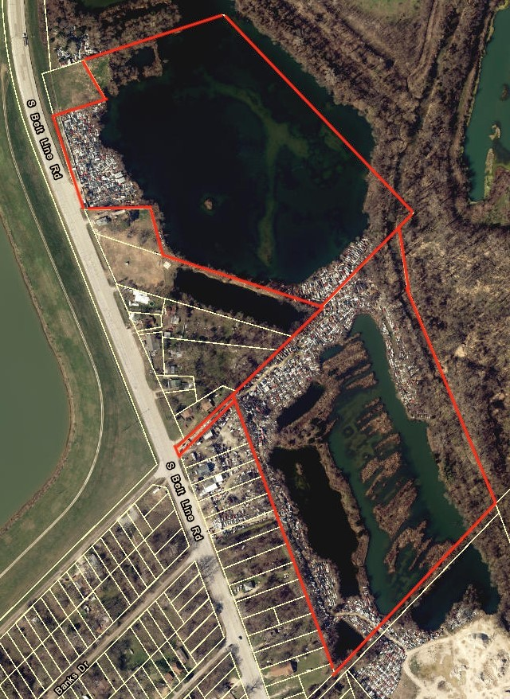

**Rickey D. Callahan, Broker Callahan Properties**

Property For Sale

3808, 4000, 4106 S. Beltline Rd. Dallas County, Texas

**Sale Price: Price Reduced to $4,495,000.00**

**8344 East R.L. Thornton Frwy., Suite 215 Dallas, Texas 75228 Office: 214.328.5775 │Ce**[**ll 214.354.1100 │ info@callahancommercial.com**](mailto:info@callahancommercial.com)

Information contained herein was obtained from sources we believe to be reliable. We make no guarantee, warran- ty or representation about it. It is subject to the possibility of errors, omissions, and change of price, rental or other conditions prior to sale, lease, financing or withdrawal without notice.

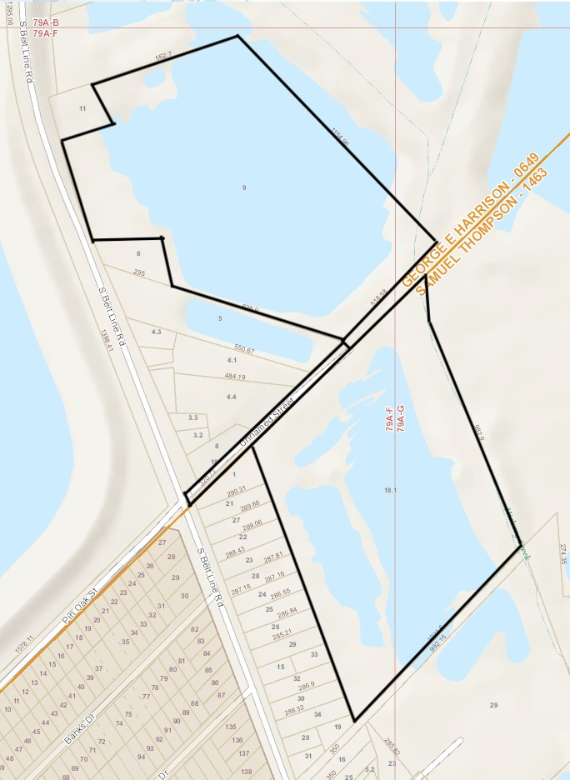

**Rickey D. Callahan, Broker Callahan Properties**

**Size**

**8344 East R.L. Thornton Frwy., Suite 215 Dallas, Texas 75228 Office: 214.328.5775 │Ce**[**ll 214.354.1100 │ info@callahancommercial.com**](mailto:info@callahancommercial.com)

Information contained herein was obtained from sources we believe to be reliable. We make no guarantee, warranty or representation about it. It is subject to the possibility of errors, omissions, and change of price, rental or other conditions prior to sale, lease, financing or withdrawal without notice.

**Total Area: 3808 S. Beltline Road 22.810+- Acres, Building: 3808 S. Beltline Road Bldg. of 700+- Sq. Ft.**

**Total Area: 4000 S. Beltline Road 0.2210+-of an Acre (Entrance Way) Total Area: 4106 S. Beltline Road 25.710+- Acres =**

**A Grand Total 48.741+- Acres**

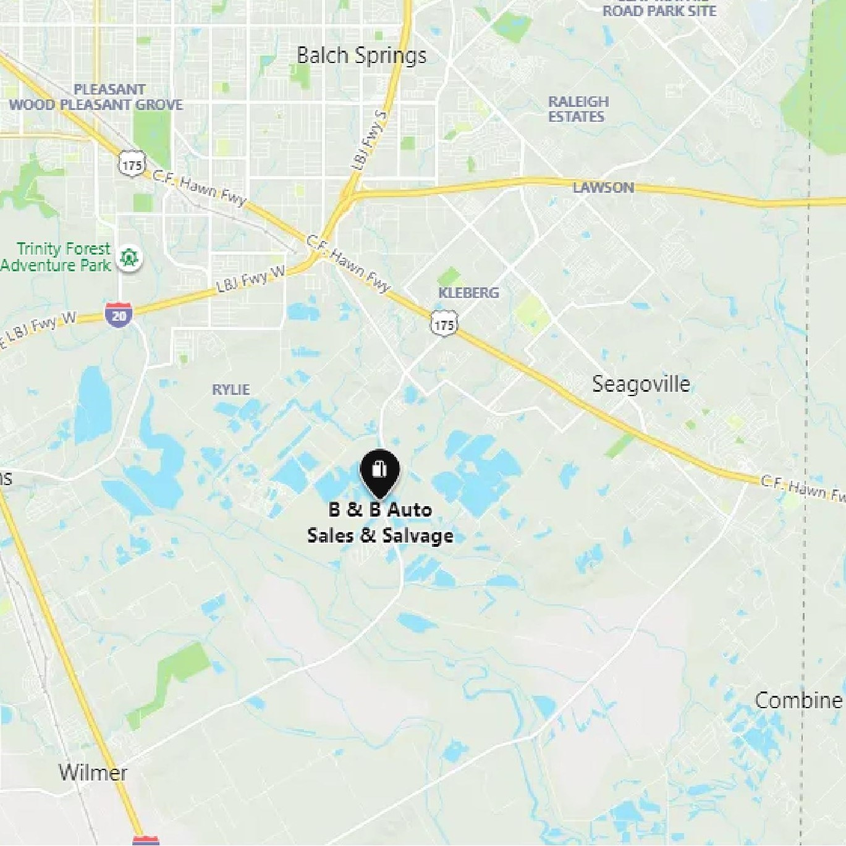

**Rickey D. Callahan, Broker Callahan Properties**

**8344 East R.L. Thornton Frwy., Suite 215 Dallas, Texas 75228 Office: 214.328.5775 │Ce**[**ll 214.354.1100 │ info@callahancommercial.com**](mailto:info@callahancommercial.com)

Information contained herein was obtained from sources we believe to be reliable. We make no guarantee, warranty or representation about it. It is subject to the possibility of errors, omissions, and change of price, rental or other conditions prior to sale, lease, financing or withdrawal without notice.

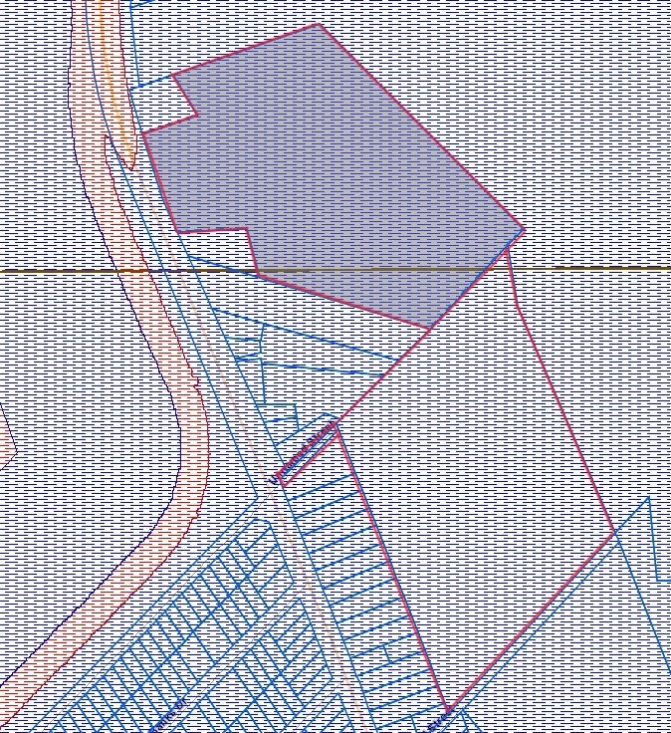

Rickey D. Callahan, Broker Callahan Properties

**Profile**

**Location:**

Subject property is located on Beltline Road., Access via I45 & Kleberg Road

**Zoning:**

Commercial Land/Commercial-Vacant Plotted Lots & Tracts

**Uses: Currently B&B Salvage Yard**

