NORTH & SOUTH VIA CEDAR CREST BLVD.
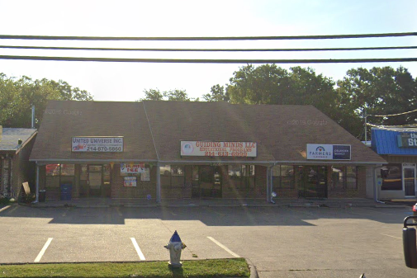
EXCLUSIVE LISTING!
PROPERTY FOR LEASE

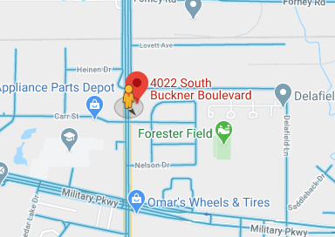
MISCELLANEOUS:
LAND:
ZONING:
UTILITIES:
ACCESS:
LOCATION:
BUILDINGS:
MAPSCO:

EAST & WEST VIA BONNIE VIEW ROAD

NORTH & SOUTH VIA CEDAR CREST BLVD.
4022 S. Buckner Blvd. Suite B
Dallas, TX 75227
EAST & WEST VIA BONNIE VIEW ROAD
NORTH & SOUTH VIA CEDAR CREST BLVD.
EAST & WEST VIA BONNIE VIEW ROAD
NORTH & SOUTH VIA CEDAR CREST BLVD.
EAST & WEST VIA BONNIE VIEW ROAD
North & South: Buckner Blvd.
East & West: I-30 & Samuell Blvd.
10,995 SF
48-Q
4,200 SF Building with Suite B of 1,562 SF

PD-366
CELL: (214) 354-1100
OFFICE: (214) 328-5775
FAX: (214) 328-6366
EMAIL: rcallahan1985@aol.com CELL: (214) 354-1100
OFFICE: (214) 328-5775
FAX: (214) 328-6366
CELL: (214) 354-1100

OFFICE: (214) 328-5775
FAX: (214) 328-6366
EMAIL: rcallahan1985@
ALL AVAILABLE TO SITE

RICKEY CALLAHAN

OFFICE: (214) 328-5775
FAX: (214) 328-6366
EMAIL: info@callahancommercial.com
8344 East R.L. Thornton Frwy, Suite 215
Dallas, Texas 75228

$1,692.00 per month
RENTAL PRICE:

Perfect for CPA, Lawyer,

Information contained herein was obtained from sources we believe to be reliable. We make no guarantee, warranty or representation about it. It is subject to the possibility of errors, omissions, and change of price, rental or other conditions prior to sale, lease, financing or withdrawal without notice.

